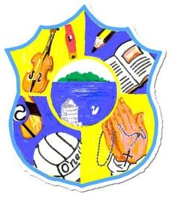  Principal: Miss R Robinson  B Ed (Hons) M ED PQH  Tel: 028 38851778 | St Mary’s Primary School  84 Maghery Road  Maghery  Dungannon  Co Tyrone  BT71 6PA
Email: info@stmarys.maghery.ni.sch.uk
23rd May 2023

Swimming P4/P5
Dear Parents,

Term 3 Swimming lessons continue for P4/P5 on Friday 2nd June and 16th June. There will be no swimming on 9th June. The bus leaves at 9.20am sharp so unfortunately, we cannot phone home for forgotten swimming gear.
As per regulation sent to us from ABC Council, children with long hair must have it tied up. Any child with verruca(s) must wear an appropriate sock or not swim.

The cost for 2 weeks is £8.00to be paid by 30th May.

Yours sincerely

R Robinson

