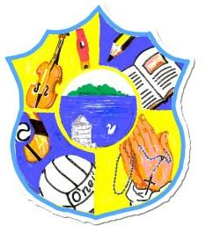  Principal: Miss R Robinson  B Ed (Hons) M ED PQH  Tel: 028 38851778  Fax: 028 38852568 | St Mary’s Primary School  84 Maghery Road  Maghery  Dungannon  Co Tyrone  BT71 6PA
26th May 2022

Dear Parents, I hope this finds you well.

Sports Day this year is Wednesday 1st June. Children should come dressed in their PE kits with a full water bottle, sun cream applied and sun hats.

Parents will be welcome to come and spectate from 1pm until 2pm. There will be a prize giving at 1.45pm.

Parents are then welcome to take their children home at 2pm. There will be no After Schools Clubs on this day.

With kind regards,

Miss R Robinson

