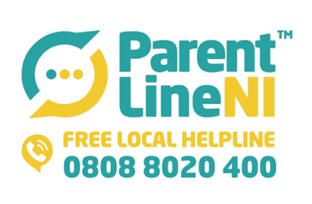

Parentline NI have teamed up with Strive NI to deliver a workshop online on Tuesday 8th March 2022  from 7pm to 8pm focussing on anxiety based school avoidance, the workshop will explore reasons why a child or young person may be finding it difficult to attend school, as well as providing practical strategies for parents/carers to support children to return more willingly to the school environment.

We have a limited number of spaces available and would appreciate if you could share the attached flyer with any parents/carers you think this would benefit and encourage them to book a place by calling our free helpline on 0808 8020 400.