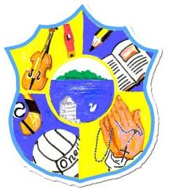  Principal: Miss R Robinson  B Ed (Hons) M ED PQH  Tel: 028 38851778  Fax: 028 38852568 | St Mary’s Primary School  84 Maghery Road  Maghery  Dungannon  Co Tyrone  BT71 6PA
14/10/20

Dear Parents,

First of all I want to take this opportunity to thank you for your support over this past number of weeks in what have been tough times for all. It has been a blessing that we have managed to keep safe and remain open, and I believe a lot of this has been as a result of every one of us being vigilant. Indeed we have a lot to be thankful for.

As many of you are aware, a statement was released today by our Education Minister Peter Weir. As a result, the children from St Mary’s will be off school from Monday 19th October for two weeks. This is an extension of the half term break and it is not for remote learning. As staff are training on the 2nd, 3rd and 4th November, the children will return to school on Thursday 5th November.

Direct payments will be made to pupils in receipt of Free School Meals for the week commencing 19th October. The school is not open to parents of key workers.

We will have a Halloween film for each class on this Friday afternoon. Children are free to bring their own treats. Make sure none of these contain nuts. We will not be dressing up as some children do not have costumes as yet. So please wear uniforms.

Some children received IEP’s and reviews home this evening. Please can these be returned to school no later than this Friday?

Wishing you the best of health and stay safe,

Miss R Robinson

