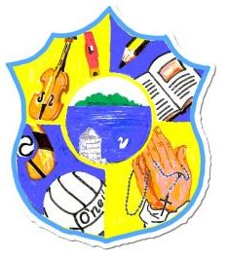  Principal: Miss R Robinson  B Ed (Hons) M ED PQH  Tel: 028 38851778  Fax: 028 38852568 | St Mary’s Primary School  84 Maghery Road  Maghery  Dungannon  Co Tyrone  BT71 6PA
21/06/2020

Dear Parents,

Schools on Friday, received a document entitled A New School Day.

At present this document is being analysed with possible scenarios being considered to ensure that the children of St Mary’s are able to return to school safely within the guidelines that need to be adhered to.

We are also conscious of the fact that this document has highlighted that the situation with Covid 19 may change over the Summer, and hence this document may be reviewed or be subject to change by DE/PHA.

We still await more legislation with regards to school transport and meals.

For these reasons we are not in a position to give you an honest picture as to what will happen when children will return to school. But we will keep you informed throughout the Summer holidays as promptly as possible.

With regards to uniforms, the document states that it is not essential for children to wear a clean uniform or fresh clothes every-day, although this should be actively encouraged.

Therefore if you are in a position to do so, please proceed with the purchase of school uniforms from Ivan Jameson. Also there will be a sale of recycled uniforms organised over the Summer. We would appreciate these to be left in this week.

I thank you for your patience. I also thank you for your support since March and the work that you have achieved with the children.

Miss R Robinson

