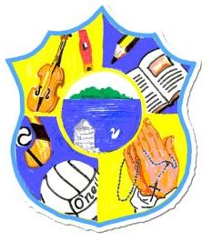  Principal: Miss R Robinson  B Ed (Hons) M ED PQH  Tel: 028 38851778  Fax: 028 38852568 | St Mary’s Primary School  84 Maghery Road  Maghery  Dungannon  Co Tyrone  BT71 6PA
09/04/2020

To all the children of St Mary’s Maghery

Dear children,

I hope you are all well and enjoying the sunny weather.
First of all the staff would like to congratulate you on the work you have been doing over this past few weeks. We know it can be difficult but we are all proud of you for trying your best.

I want you to know that staff miss having you around the school. When we have been in school preparing work and the break or lunch bell rings, there is silence, and we miss all the noise and laughter. The school is not the same without you.

Yes it is important to keep up your school work but there are a number of other things I would ask you to think and do in the time you are not at school.

Firstly, if you are not already doing so, say a little prayer every day that everyone remains safe at this time. Say one also for those doctors, nurses, care workers, lorry drivers, shop workers and others, that are working so hard to make sure everyone is being well looked after. I know many of your parents are in these jobs and I just want you to know we are all saying a prayer for them every day.

Secondly, try to help your parents as much as you can. You can do this by completing your work for them, helping them with little jobs around the house, and also by helping your brothers and sisters with their work as well.

Thirdly, try to do something different, perhaps something you have never tried before. At present, I’m trying to become better at computers. I know some of you are baking and growing your own vegetables. I’m trying to bake as well! Also try to enter the Art competitions that are on our web-site, and the competition that has been organised by Maghery Sean McDermott’s football club. It’d be great to win a prize!

Children this is Holy Week. Ask your parents to tell you about what happened on Holy Thursday, which is today, Good Friday and Easter Sunday. Perhaps to find out more, look up the children’s bible versions online. This is how Easter came about and it is important to know this.

Lastly, to enjoy Easter. Enjoy the great weather. I’m confident the Easter bunny will come to all of you. Remember to enjoy your Easter eggs but don’t eat too many!

Thinking of you all

Miss Robinson and the staff of St Mary’s Maghery

