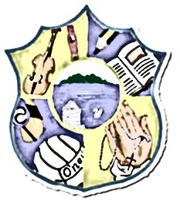  Principal: Miss R Robinson  Tel: 028 38851778  Fax: 028 38852568  B Ed (Hons) M Ed PQH | St Mary’s Primary School  84 Maghery Road  Maghery  Dungannon  Co Tyrone  BT71 6PA
16/03/2020

Dear Parents,

Today, we awaited an up-date from the Education Minister Peter Weir with regards to the Covid-19 Virus and its impact on schools and education. At the weekend, contact was also made with EA and local councillors highlighting issues that we feel need to be addressed with immediate effect.

Staff have been working assiduously over the past few days considering and applying the best methods we can, to ensure that children receive the highest standards of education possible. We also recognise that we have a duty of care to our children’s health and that of the wider community, especially the elderly and those who have underlying health conditions.

As the decision of the Education Minister has remained unchanged, St Mary’s Primary School will close for children on Wednesday 18th, Thursday 19th and Friday 20th March, bringing forward some of our Staff Development Days, to allow staff to meet and to put measures in place to allow for learning, in the event of long-term closure being imminent. We will inform you in the foreseeable future with regards to how the school calendar and teaching days may change. We apologise for such late notice but know you realise that these are difficult and unprecedented times for us all.

Please keep up-dated with us through our Schools NI App.

Thank you for your support and wish you all the best of health in this current and frightening situation.

Miss R Robinson

