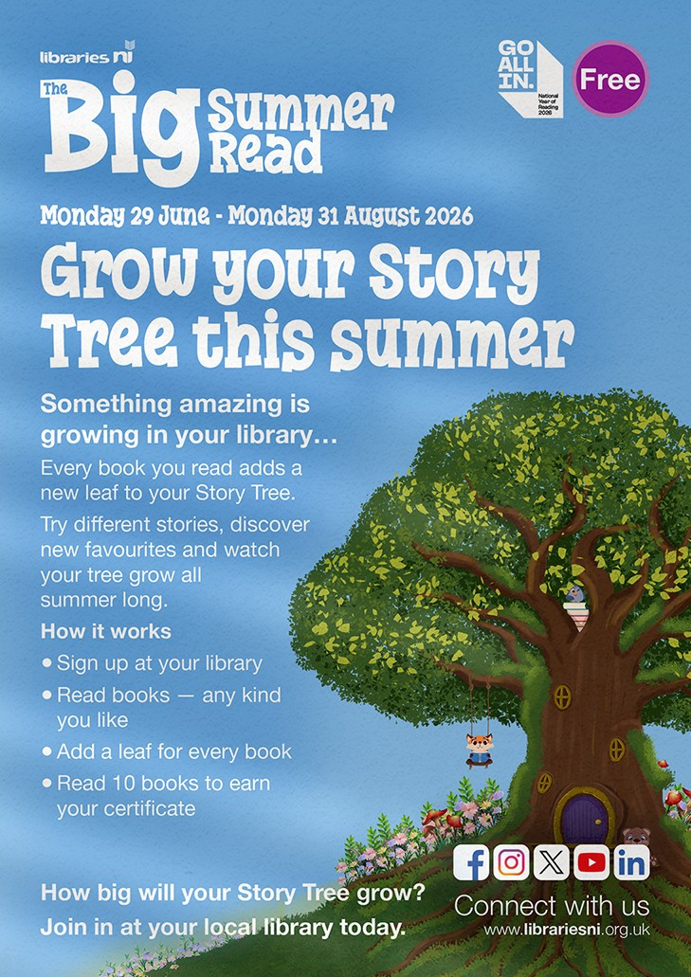
BIG SUMMER READ 2026
Subject: Big Summer Read 2026 – Supporting Pupils Over the Summer

Dear Schools

I am getting in touch to let you know about this year’s Big Summer Read
delivered by Libraries NI, and to ask for your support. The programme, which
is targeted predominantly at primary school–age, encourages children to
continue reading over the summer months. This year’s theme,
The Story Tree, is designed to be flexible and accessible, allowing children
to read at their own pace and follow their own reading interests.
Maintaining reading over the summer period can be a challenge, and the
Big Summer Read provides a simple, free way for families to get involved.
This is particularly important as this is the National Year of Reading and during
2026 everyone is being encouraged to take time to read. Children that read 5
books will get a bookmark, and those that read ten books will get
a certificate acknowledging the achievement and this can be celebrated in
school.

The programme will run from 29 June to 31 August 2026, and children
can take part by signing up
at their local library.

