Healthy Kidz - Term 2 (January 2026)

P1 – P3 – Multi Sports

P4 – P7 - Soccer

Good Morning

Please find attached the new flyer & link that can be shared with parents.

https://activities.bookpebble.co.uk/activity/healthy-kidz-st-marys-ps-maghery-term-2-2026-dungannon-c1aa2a4a-f899-411b-8232-45675fd875ba

Many Thanks
Niall
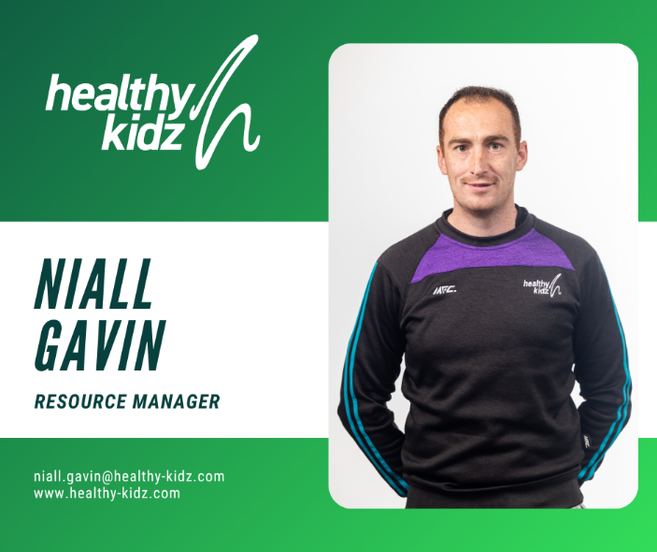
Niall Gavin
Resource Manager at Healthy Kidz CIC - Northern Ireland's Leading Physical Activity Coaching Provider

Helping every child achieve their best possible state of well-being
Web www.healthy-kidz.com

