St Mary’s Maghery
JUST SOME OF WHAT WE OFFER IN ST MARY’S
- Excellent standard of Education
- Excellent ICT
- Excellent standard of Pastoral Care 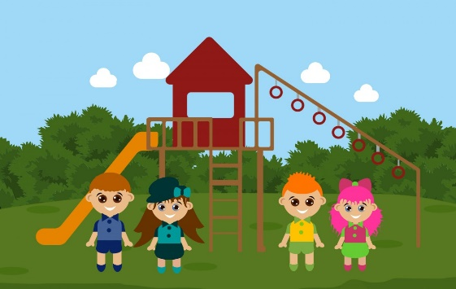
- NSPCC Ambassadors
- Healthy Happy Minds
- Tuition for Transfer Tests
- Excellent range of After School’s Clubs
Golf
Cookery
Sports including Gaelic Football
ICT
Art

- Daily breakfast club commencing at 8.15 am
- Loughshore Playgroup on site
- Winners of three Green Eco Flags
- Sustrans Ambassadors
- Excellent Eco and Outdoor Planting facilities
- Music Tuition in Strings and Wind Instruments
- Newly established Games Pitch
- Shared Education
- A staff who want the best for the children in their care!

“In St Mary’s staff are hard-working and committed. They know each child, their strengths, their needs and their personalities. The school is excellent and I know I made the correct choice sending my child to this school.” Parent of Foundation Stage child
“St Mary’s is an up and coming thriving little school. I would have no hesitation in recommending it to any parent. My child and I feel very valued.” Parent of KS1 Child
Applications for St Mary’s opens on 10th January 2022. Applications can be made by visiting www.eani.org.uk/admissions
Should you wish to find out more about life in St Mary’s, please do not hesitate to ring us on 02838851778 to arrange a visit. You are also very welcome to visit our school website www.stmaryspsmaghery.co.uk or our Facebook Page Friends of St Mary’s Maghery

St Mary’s Primary School Maghery
“Achieving excellence together”

School Principal: Miss Rita Robinson BEd (Hons), MEd, PQH

