[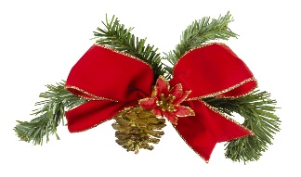](http://www.google.co.uk/url?sa=i&rct=j&q=&esrc=s&source=images&cd=&cad=rja&uact=8&ved=&url=http://www.springhillfresh.com/spring-hill-academy-preschool-holiday-special/&psig=AOvVaw00HKOCx4kxu9bIt3mx1DVR&ust=1512049366115146) [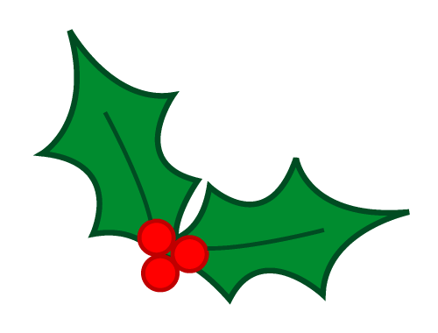](http://www.google.co.uk/url?sa=i&rct=j&q=&esrc=s&source=images&cd=&cad=rja&uact=8&ved=&url=http://www.stjmontclair.org/event/greening-church-2&psig=AOvVaw3GR8TWzBYGmztENkAyMQPC&ust=1512119204448387) **CHRISTMAS RAFFLE**

1. Family Portrait -Donnie McGale - £250 -Katie Convie
2. Vivofit Watch - £75 -Philomena McBride
3. Signed Armagh Jersey -Dylan Bailey
4. Christmas Cake made by Jean Fox -Connor Fox
5. Voucher from Begleys Dungannon -Tara Donnelly
6. Avon Hamper -Bella Rafferty
7. Ghost Fragrance Set -Matthew Baird
8. Voucher Tervor Irwin £25 -Justin Fox
9. Voucher The Loft (Linen Green Complex) -Bernie Mulholland
10. Voucher Ryandale Moy £20 -Aine Robinson
11. Voucher Hair by Jade -Dee Skelton
12. Voucher Tom Morrows £20 -Aine Cushnahan
13. Voucher Ciara’s Nails -Toni McCourt
14. Voucher Tennyson Décor shop -Angela O’Connor
15. Litre Bottle of Smirnoff Vodka -Sinead Dynes
16. Sweet hamper -Kyla Fox
17. Bottle of Wine -Pearse Fox
18. Box of Sweets -Margaret Campbell
19. Candle -Shea Skelton
20. Wooden Deer -Lisa Cushnahan
21. Wooden Deer -Eamon McNeill