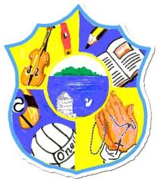  Principal: Miss R Robinson  B Ed (Hons) M ED PQH  Tel: 028 38851778 | St Mary’s Primary School  84 Maghery Road  Maghery  Dungannon  Co Tyrone  BT71 6PA
Email: info@stmarys.maghery.ni.sch.uk
14th November 2023

Swimming P6 / P7
Dear Parents,

Term 2 Swimming lessons will start for P6/P7 on Friday 12th January 2023 for 5 weeks. The bus leaves at 9.20am sharp so unfortunately we cannot phone home for forgotten swimming gear. As per regulation sent to us from ABC Council, children with long hair must have it tied up. Any child with verruca(s) must wear an appropriate sock or not swim.
The cost for 5 weeks is £20.00 to be paid by 8th January 2023.

Yours sincerely

R Robinson

