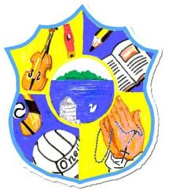  Principal: Miss R Robinson  B Ed (Hons) M ED PQH  Tel: 028 38851778  Fax: 028 38852568 | St Mary’s Primary School  84 Maghery Road  Maghery  Dungannon  Co Tyrone  BT71 6PA
10th February 2023

Dear Parents,
Dress Up Day
To celebrate World Book Day on Thursday 2nd March, our children will be encouraged to use re-cycled materials only to make their costume.
Our school will be re-applying for our Green Flag accreditation from Eco-Schools in March this year. As this coincides with World Book Day celebrations, we thought this would be a perfect opportunity for our children to promote their ‘Eco Warrior’ status by repurposing and recycling materials found at home, to design and wear their very own unique fairy-tale/nursery rhyme themed creation.
Recycling items found at home e.g. clothes, material, carboard, plastic containers etc will promote the reuse of precious resources and help to reduce gas house emissions, as well as plastic waste. Did you know that some clothes can take up to 200 years to decompose? A cotton t-shirt may take a few months, however if you add polyester to the mix (which most costumes are made of), this number increases to over 200 years. We look forward to seeing the children’s wonderful creations.
Book Sale
On a final note, we will hold our annual book sale on World Book Day. There will be a selection of fiction and non- fiction books available for all age ranges, priced from £1-£2. Sticking with our recycling theme, please feel free to donate any old books that you no longer use or need.
Kind Regards
Kathleen Delaney

