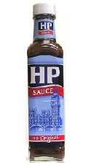 Bottle Stall 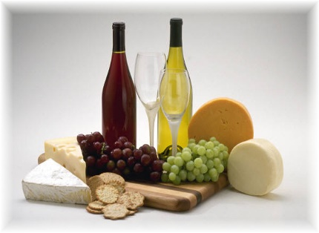
Hello everyone. We are hoping to run a bottle stall on our Fun/Open Day at Halloween (details to be provided) Below is some of the examples of items that have been donated in previous times:

- Hygiene/Makeup
- WD 40/ trade products
- Kitchen Products
- Alcohol
- Makeup products
- Cooking products such as HP Sauce

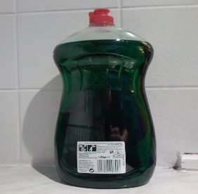
Please have a hunt around the house. Something you might not want might be someone else’s treasure!!!

