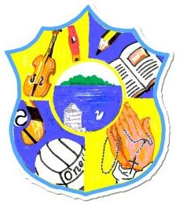  Principal: Miss R Robinson  B Ed (Hons) M ED PQH  Tel: 028 38851778  Fax: 028 38852568 | St Mary’s Primary School  84 Maghery Road  Maghery  Dungannon  Co Tyrone  BT71 6PA
11/06/2021

Dear Parents,

I trust this finds you all well.

Classes for next year:

Mrs Copeland/Miss Campbell - Primary 1,2&3
Miss Robinson – Primary 4&5
Mrs Delaney – Primary 6&7

Mrs Delaney comes to St Mary’s Maghery with a wealth of experience. She is looking forward to her new post, working alongside staff, pupils and parents in continuing the high standards of education and pastoral values that we adhere to.

On behalf of everyone, I wish Mrs O’Keefe the best of luck in her new post in St Anthony’s Primary School Craigavon.

During the coming week we will participate in a range of activities to celebrate 50 years of Cumann na mBunscol. On Tuesday, children will partake in GAA skills day. On Thursday, children can wear their club or county colours to school. Key Stage 2 will also work on a profile of their favourite county player.

Mrs McAvera is working hard finalising a very special celebration and memorabilia for our Primary 7 children. After Mass on Friday, please can all children make their way to the old chapel to have some photos taken beside the beautiful cross they have created.

Yours in good faith

Miss R Robinson

