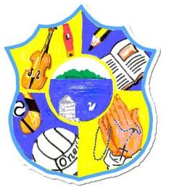  Principal: Miss R Robinson  B Ed (Hons) M ED PQH  Tel: 028 38851778  Fax: 028 38852568 | St Mary’s Primary School  84 Maghery Road  Maghery  Dungannon  Co Tyrone  BT71 6PA
09/02/2021

Dear Parents,

I hope this finds you all well.

First all of on behalf of the staff I again wish to thank you for working alongside us with remote learning. It has been tough on everyone. We are all hoping that it will end very soon and that our children will be able to return to the classroom. We will keep you up-dated on any correspondence from Mr Weir and his team.

I am sure you are all looking forward to a well-earned break at mid-term. Remote learning will return on Monday 22nd February for all. However feel free to use any on-line learning tools such as Reading Eggs, Lexia and Sumdog over the break.

It was great to get a chat today with Primary 4’s. All of the teachers plan to get chatting to their class throughout the week. Please check out Seesaw and Google Classroom for details.

We congratulate Mrs Copeland on the great news of her pregnancy. When face-to-face teaching resumes, Miss E Campbell will be the new teacher for our Primary 1 and 2 class.
Miss Campbell has been part of our staff since September 2020 and is a valuable asset to our school. She knows all of the children. Both teachers are currently working hard on preparations for her new role with Primary 1 and 2’s.

The school will continue after half-term, to remain open for the children of key workers who are working. As we all know by now, in order to prevent the spread of Covid, please only avail of this service if it is a necessity. Please make contact with the school on the Thursday of the previous week before noon, to book a place.

Wishing you all the best. Keep praying and stay safe.

Miss R Robinson

