Hello Principals,

I am delivering a 6 week SafeFood funded project called 'Transform your Trolley'.

SLNRA is one of 13 Healthy Living Centres delivering projects to tie in with a national campaign looking at how to shop smart from a financial and a health perspective.

The project will start next week and will be a mix of Tuesday evening sessions and Saturday mornings. Families will learn how to shop savvy and put these skills to use by shopping for recipes that they will then join us to cook as a group online.

We have been delivering online cooking sessions for families since the summer and they have been incredibly popular, particularly with the children.

We would love to have at least one family from each primary school attend to ensure that we are reaching families all around the area. Would it be possible for you to let your families know via text/ Seesaw etc? Ask them if they want to be one of the families to represent the school to try and talk it up a bit?

This is the link for them to register, and I will attach the poster too.
https://forms.gle/1zwtUwJfoR2nATnq5
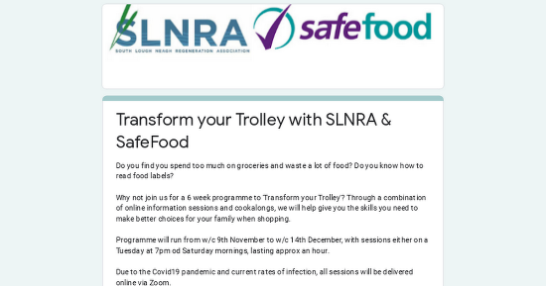 | Transform your Trolley with SLNRA & SafeFood  Do you find you spend too much on groceries and waste a lot of food? Do you know how to read food labels? Why not join us for a 6 week programme to 'Transform your Trolley'? Through a combination of online information sessions and cookalongs, we will help give you the skills you need to make better choices for your family when shopping. Programme will run from w/c 9th November to w/c 14th December, with sessions either on a Tuesday at 7pm od Saturday mornings, lasting approx an hour. Due to the Covid19 pandemic and current rates of infection, all sessions will be delivered online via Zoom.  forms.gle

Thank you in anticipation,

Claire Hackett

--
Claire Hackett
Community Development Officer
South Lough Neagh Regeneration Association
Unit 1 Maghery Business Centre
Maghery Road
BT71 6PA
Tel: 02838 852550

