Hello Principals,

I hope you are all well and everything is going well for the return to school.

I have been conscious that you all will have had a lot on your plates trying to plan for the return without guidelines and in an ever- evolving situation and so I have been reluctant to ask you all to help with this.

At SLNRA, we want to try and obtain funding to deliver a project that will support local families post- Covid. Ideally we would like to secure funding at a level that would enable us to deliver a smaller, shorter version of our much- loved Loughshore Family Action Project.

To do this, we need feedback from the community and we have had a survey up online. However, we would like a few more responses and I was wondering if you could have it shared with your parents? This is the link: https://forms.gle/hCCvjtTb9cutFeuDA
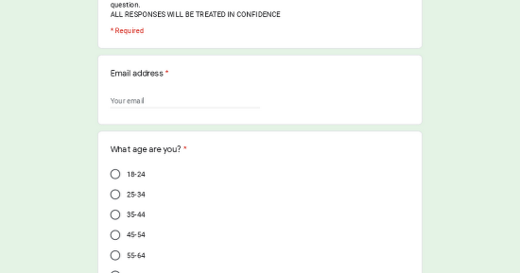 | SLNRA Covid19 Community Survey  SLNRA recognises that the community will face challenges in returning to life after the period of 'lockdown' due to the Covid19 pandemic. The information that you provide in this survey will enable us to identify the needs of the Loughshore community and hopefully provide services to support the community going forward with 'life after lockdown'. PLEASE NOTE: if any questions are too sensitive or are not relevant, please just skip the question. ALL RESPONSES WILL BE TREATED IN CONFIDENCE  forms.gle

Your help would be much appreciated.

Yours,

--
Claire Hackett

South Lough Neagh Regeneration Association
Unit 1 Maghery Business Centre
Maghery Road
BT71 6PA
Tel: 02838 852550

