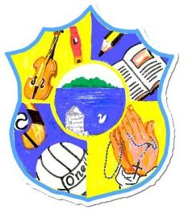  Principal: Miss R Robinson  B Ed (Hons) M ED PQH  Tel: 028 38851778  Fax: 028 38852568 | St Mary’s Primary School  84 Maghery Road  Maghery  Dungannon  Co Tyrone  BT71 6PA
26/08/2020

Dear Parents
I hope this finds you all safe and well.

Thankfully things are going relatively to plan for us and we are doing our upmost to keep everyone as safe as possible. I want to thank you for your support in helping us with this.

The nurse will be at school at school on the 7th October 2020 to give the flu vaccine. Forms will be sent out and please return these as soon as possible. With the current pandemic, it is very much recommended by PHA that every child who is eligible receive this vaccine.

In order to increase safety for everyone, we have been able to purchase thermometers for each classroom. Staff have been trained and will be able to use them from Tuesday 1st September onwards. Everyone’s temperature will be taken when they enter the classroom. This includes staff. I hope that this will also help to ease your worries at this time.

Staff will be providing children with more details this week on on-line learning. This is for home-works. This will allow staff to have more interaction with the children, and will be something that will be used as our main tool for learning and communication with parents and children should the occasion arise that the school has to close.

The school bell will ring at 9am. Please do not let children enter onto the premised until the bell rings and an adult is on supervision. The gates will close at 9.15am sharp. Again this is all to keep everyone as safe as possible.

On behalf of the staff and Board of Governors I want to again offer my appreciation for your support.

Miss R Robinson

