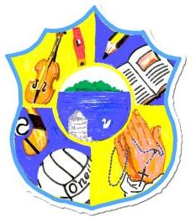  Principal: Miss R Robinson  B Ed (Hons) M ED PQH  Tel: 028 38851778  Fax: 028 38852568 | St Mary’s Primary School  84 Maghery Road  Maghery  Dungannon  Co Tyrone  BT71 6PA
20th October 2023
info@stmarys.maghery.ni.sch.uk

Dear Parents and children,

Maths week

Today brings an end to Maths week. What a full-filled and memorable week of learning it was, concluding with a bingo and pass the parcel to get us in to the Halloween spirit.

I want to thank all the staff for the huge amount of time and energy they dedicated to ensuring this week was a success. I got the impression that they enjoyed it too however! To our parents; thank you for your efforts with the homework’s. We got some super feedback from our children about the home activities. We thank you also for any financial contributions.

Finally to the children; your efforts, your laughter and excitement, and your ability to work as a team made it all worthwhile for staff. We hope you enjoyed the week too! We already are looking forward to next year. Thank you.

Primary 4&5 visit the Diamond Club

On Thursday past, our Primary 4&5 children paid a visit to the Diamond club, courtesy of an invite from Ms Hazel Boland, Loughshore Care Partnership. The photographs on our facebook page highlight the great time we had. It is an honour to be able to work with both groups. Not surprisingly, the behaviour and contribution our children made towards the day was commented upon favourably by all.

Dress Up Day

Wednesday 25th is the last day before the Halloween break. It is a dress up day. Children can bring a few treats. There will be no PE this day.

After-Schools Clubs
These have ceased until after Halloween. Patricia has dates of new clubs on the school web-site. These clubs are now open to Primary 1 children.

On behalf of everyone we wish you a safe and enjoyable Halloween break.

Miss R Robinson

