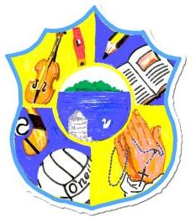  Principal: Miss R Robinson  B Ed (Hons) M ED PQH  Tel: 028 38851778  Fax: 028 38852568 | St Mary’s Primary School  84 Maghery Road  Maghery  Dungannon  Co Tyrone  BT71 6PA
12/09/2022

Dear Parents,

Covid

There have been confirmed cases of Covid within the school.
Symptoms are
- High Temperature
- Shivering
- Continuous cough
- Loss of Taste/Smell
- Feeling tired/Exhausted
- Aching body
- Headaches
- Blocked/Runny Nose
- Feeling or Being Sick

If your child has any of these symptoms you are advised to test your child for Covid using Lateral Flows and follow PHA Guidelines.

Tummy/Vomiting Bug
PHA Guidelines state that a child must be kept off school until 48 hours after the last episode of the bug.

Monday 19th September
Is a Bank Holiday and there will be no school.

Old-tee-shirts/Aprons for Art work – please can these be sent in.

We appreciate all your support in working with us on the above.
Kind regards, Miss R Robinson

