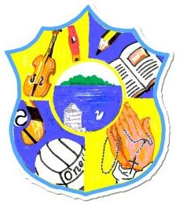  Principal: Miss R Robinson  B Ed (Hons) M ED PQH  Tel: 028 38851778  Fax: 028 38852568 | St Mary’s Primary School  84 Maghery Road  Maghery  Dungannon  Co Tyrone  BT71 6PA
07/06/2022

Dear Parents,

I hope this finds you well.

We are now in to our third term of the school year which is a very busy time for us all. Again I thank you for all your commitment and support throughout the past year.

The classes for next year are as follows:

- Primary 1,2&3 Mrs Copeland (Mrs Mackle will be teaching this class on Wednesday’s)
- Primary 4&5 Miss Robinson (Mrs Mackle will be teaching on Tuesday’s and Thursday’s)
- Primary 6&7 Mrs Delaney

Reports are currently being drawn up and will be posted. Please can you ensure that the school has your most recent address? Please return the reply slip to the school with your child.

Primary 7’s Leavers Mass will be on Tuesday 21st June in Our Lady Queen of Church at half 10. There will be some refreshments for children and their parents afterwards in the school. Primary 7’s can head home with their parents afterwards should they wish. School will officially finish for Primary 7’s on Friday 24th June. School will finish for Primary 1-6 on Thursday 30th June at 11am.

Mrs Copeland will shortly be corresponding with the parents of our new Primary 1 children of September 2022.

Please remember to keep abreast of daily events via our School Website and Facebook page.

Please can any outstanding/current reading books be returned to the school by Friday 17th June to allow us to organise our store for the next academic year?

Yours in good faith

Miss R Robinson

